Lab 7
Date Assigned: 10/19/2015
Lab Report Due: Midnight 10/26/2015 on iLearn

- You may want to bring your textbook to labs to look up syntax and examples.
- Have a question? Ask your instructor for help, or look at the book or past lecture slides.
- We encourage you to talk to your classmates; it's okay to discuss ideas (but NOT copy code) during lab.
- You probably won't finish all of the exercises. Do as much as you can in the allotted time. You NEED to finish the rest after you leave the lab.
- Before you leave, SHOW your work to your instructor to get credit for your work in lab.
- Complete all sections and turn in a report to iLearn before the deadline. See turn-in check list (at the end of this document) for more details.
- For each lab, lab attendance and your work during lab 40%, lab report 60%.

Section 1: HTML Form
HTML has a tag <form> that is used as a container to package data to communicate with the web server.

<form id="formexample">

<p>Please enter your age: </p>
<input id = "age"> <br>

<p>Which year are you in? </p>
<input type="radio" name = "year"> Freshman <br>
<input type="radio" name = "year"> Sophormore <br>
<input type="radio" name = "year"> Junior <br>
<input type="radio" name = "year"> Senior <br>

</form>

- Create a folder lab7 on the desktop. Create a page section1.html that includes code in the above example, and save it in lab7. View the page in Chrome.
- Let’s create a new form. In section1.html, add the following code:
<form id="inputelements">

</form>

A HTML form can contain various HTML elements. As you will notice, the most common element is <input>, which, based on the value for its attribute type will display a different kind of input.
Text fields
- Add the following code into the form (id “inputelements”) container in section1.html :
<input>
View the page in Chrome.
- Let’s add a message before the input box (again, in the form (id “inputelements”) container), so that the user knows what to enter; add a <br> after the input box, so that this input box can be displayed independently on a line.
Please enter your name: <input> <br>
View the page in Chrome.
Radio buttons
- Add the following code into the form (id “inputelements”) container in section1.html :
<p> Your gender: </p>
<input type="radio"> Male <br>
View the page in Chrome.
- Add another radio button in the form (id “inputelements”) container that looks like
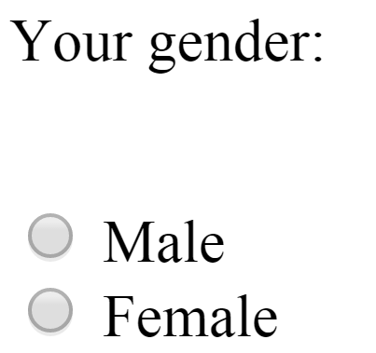
Check boxes
- Add the following code into the form (id “inputelements”) container in section1.html :
<input type="checkbox"> I have been to Marist before.<br>
View the page in Chrome.
- Add more check boxes into the form (id “inputelements”) container in section1.html that looks like:

Date input boxes
- Add the following code into the form (id “inputelements”) container in section1.html :
<p>Enter your birthdate:</p>
<input type="date"> <br>
View the page in Chrome.
Time input boxes
- Add the following code into the form (id “inputelements”) container in section1.html :
<p>Enter the time you got up this morning:</p>
<input type="time"> <br>
View the page in Chrome.
Text boxes
- Add the following code into the form (id “inputelements”) container in section1.html :
<textarea> You can type here</textarea> <br>
View the page in Chrome.
Buttons
- Add the following code into the form (id “inputelements”) container in section1.html :
<button>Click me</button> <br>
View the page in Chrome.
Drop-down list
- Add the following code into the form (id “inputelements”) container in section1.html :
<p>You are living in: </p>
<select>
<option>NY</option>
<option>PA</option>
<option>NJ</option>
<option>CA</option>
</select>
<br>
View the page in Chrome.

Section 2: Useful Attributes in HTML Form

The two most important attributes that we will use very frequently in HTML forms are name and value.

Name
View section1.html in Chrome. We made two radio buttons:
Click “Male”, then click “Female”. It is supposed that the user can only choose one of them. However, in our current form, both buttons can be selected at the same time. Important: Radio buttons should be grouped by name attribute (radio buttons should have the same name), so that only one can be selected at a time. Without the same name, radio buttons will not be mutually exclusive.

- Add a name attribute to radio buttons male and female in the form (id “inputelements”). Let name be “gender”.
View section1.html in Chrome. Click “Male”, then click “Female”. Now you should be able to select only one of them at a time.
Show your work to the instructor before you work on the next step.

Value
View section1.html in Chrome. We made an input box that allows the user to enter his/her name:
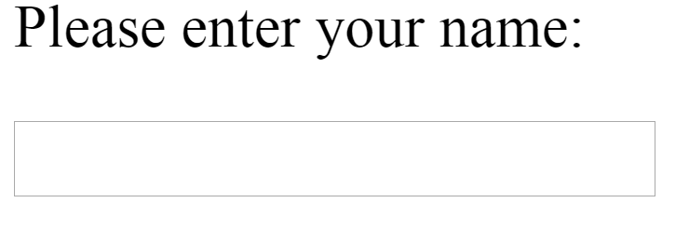
We can add a value attribute to give an initial value to the input box. This initial value in the text field can be overwritten by the user.

- Add a value attribute to input box (the one after “Please enter your name”) in the form (id “inputelements”). Let the initial value be “Mickey Mouse”.
View section1.html in Chrome.

Placeholder
Another useful attribute for input is the placeholder, which can be used to provide a hint for the kind of value that should go in a field. For example,
<input placeholder="Enter your name">
will be rendered like this:
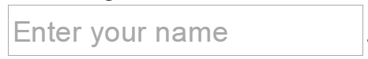

Section 3: Handling Forms Fields with Javascript
Whenever we interact with a page, we do that through the mouse or the keyboard. The operations we perform in these cases are known by the computer as events: when we click on something, hover, move the mouse inside or outside a certain area, type a key on the keyboard, scroll the page, check a radio button, choose an item from a drop-down select element, input text in a field, change the value of a number field, etc.

When an even happens, it is up to the programmer then to decide whether he/she wants his/her page (or application) to respond to such a trigger event. Responding to the event triggering is known as handling the event, and the code that will do this is called an event handler. We will write event handlers with Javascript code.

Inline Javascript Event Handlers
An inline event handler looks like the example below:
<button onclick="alert('I was clicked!');">Click me</button>
Notice the event attribute onclick, to which we attached the event handler code that will display an alert pop-up dialog.

- Add the above code into the form (id “inputelements”) container in section1.html. Click the button, and see how JS handles the “click” event.
- In section1.html, change the content of button you added at step 16 from “Click me” to “test button”. Refresh the webpage, and observe the changes.
- In section1.html, change the Javascript code of button you added at step 16 from “alert('I was clicked!');” to “console.log(' I was clicked!');”. Refresh the webpage, open the console, and click “Preserve log”, to see the message.
- In section1.html, add one more button into the form (id “inputelements”) container, such that if you click on the button, it will display a message “I love Javascript!”.

The special variable this
Whenever an event occurs, the browser knows not only what kind of event happened (a click, a key press, etc.) but also the element that the event happened to. Such an element is called the target of the event. In Javascript, the target element can be referred within the event handler with the special variable name this.
<button onclick="alert(this.innerHTML + ' was clicked.');">Winter</button>
this.innerHTML refers to the content of the target element <button>, which is “Winter”.

- Add the above code into the form (id “inputelements”) container in section1.html. Click the button, and see how JS handles the “click” event.

External Javascript Event Handlers
- Create an empty Javascript file, name it “section1.js”, and attach it to section1.html.
- Add the following code to the form (id “inputelements”) container in section1.html.
<p> Where do you come from? </p>
<input id="hometown" placeholder="Enter your hometown">
<button type="button">Submit</button> <br>
View section1.html in Chrome.

What we are going to in the following is to describe an event handler in an external JS file to respond to the button click event of “submit” button just we added. The event handler will read what user has entered in the input box right before the “submit” button.

- First, we need to add an attribute “onclick” to the button you added at step 22 in section1.html which allows us to attach an event handler to the button. Let the value of “onclick” be “clicksubmit();”, where “clicksubmit()” is name of a Javascript function which we will define in the external Javascript file.

A function allows us to package up many lines of code in one chunk, give it a name, and invoke it whenever we want. Invoking a function means to run it (execute the code). You have seen several examples of Javascript built-in functions so far, alert(), prompt(), parsetInt(), etc. The difference is that we will have to define our own functions and then invoke them.
- Now let’s define our own function “clicksubmit()” in the external Javascript file section1.js.
function clicksubmit() {
// read value from input box with id “hometown”, and save it in a variable called home
var home = document.getElementById('hometown').value;
// display the value of input box using alert
alert("Oh, you come from "+ home);
}
We use document.getElementById("idvalue") in Javascript to refer to a specific element in HTML. In this case, document.getElementById("hometown") refers to the element in section1.html with id “hometown” (which is an input box), and document.getElementById("hometown").value refers to what user has typed in the input box of “hometown”. We save the value in a variable home, and use it in the alert() function.
View section1.html in Chrome.
Show your work to the instructor before you work on the next step.
- Add code to the form (id “inputelements”) container in section1.html to ask the user about his/her major, and let user type the answer in an input box. Give the input box an id.
- Add a button type of “button” similar to the one you created at step 22. Add an “onclick” attribute to the button. Let the value of “onclick” be “clicksubmit2();”, where “clicksubmit2()” is name of a Javascript function which we will define in the external Javascript file. In JS, we name a function following the rules of variable names.
- In section1.js, add the definition of “clicksubmit2()” following the format of
function clicksubmit2() {
// add code here
// You need one statement to read value from input box you created in step 25, and save it in a variable
// You need another statement to display the value of input box using alert

}
to display what user has typed about his/her major in an alert box.
View section1.html in Chrome.

TURN-IN CHECKLIST:

- Source Code (.html/.css/.js files) created in this assignment. Remember to include your name, the date, and the lab number in comments near the beginning of your code.

Create a folder and name it 'FirstName_LastName_lab_7'. In the newly created folder copy and paste your source code (.html/.css/.js files). Then compress the folder, and upload it to iLearn.

